# Archi - ArchiMate Modelling

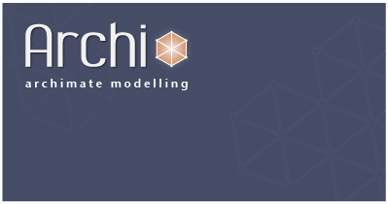

**What’s New in Archi Versions 2.1 - 2.2.3**

# Important Note

It is always a good idea to make backup copies of your data before installing a new version of Archi. Whilst we make every effort to test the software and check for bugs we cannot guarantee that bugs do not exist in the application nor that your data might be affected by changes in this version of Archi.

Please backup your data first!

## Fixes in version 2.2.3

* Fix global key bindings not cleared when editing new View added in Models Tree

## Fixes in version 2.2.2

* Fix global key bindings not cleared in Search bar and Zoom combo

## New Features in version 2.2.1

* When adding a new element from the Palette you can now immediately edit the element's name (can be turned off in Preferences)
* Allow WorkPackage and Plateau types to connect to Junctions

## Fixes in version 2.2.1

* Typo fixes
* Buttons and labels in Properties window can accommodate longer strings (as used by non-English localised versions)
* Tidy up some Properties window controls
* Archisurance example now complies with ArchiMate 2.0
* Fix pressing "x" cancel on Save confirmation dialog does not cancel

## New Features in version 2.2

* Support for ArchiMate 2.0
* Model Tree selection synchroniser can now select active View in Model Tree

## New Features in version 2.1

* Canvas Modelling Toolkit
* ArchiMate connection tooltips now display the full meaning of the relationship
* Cut/Copy/Paste/Select All shortcut keys now work in elements' label editors
* Holding down a key (Ctrl on Windows and Linux, Alt on Mac) when dragging elements from the Models Tree to a View ensures connections are not added
* Shortcut keys implemented for Mac OS X Lion full screen. Also menu item added to main "Window" menu
* The Backspace key is now bound to the Delete command on Mac OS X
* The F1 key now invokes dynamic help on Mac OS X
* Improved Diagram Connection Line Styles
* A Relationship's name is now used as the text on a connection

## Fixes in version 2.1

* BiZZdesign Architect Import/Export is no longer supported
* Fixed "Bring Forward" and "Send Backward" commands to move only one position in Z-order
* Fixed unnecessary page breaks in Jasper Reports
* The "Add to my template collection" option is now enabled by default in the "Save As Template" wizard
* Improvements to Template management
* "Save Model As Template" wizard: Fixed template could not be added to template collection if no user category selected
* "Save Model As Template" wizard: File location is set in wizard, not in separate dialog
* Fixed error when tooltips disabled in Preferences and View contained Access Relationship
* Business Event type is allowed in Application Usage Viewpoint
* Fixed crash when editor is in Full Screen mode and "Undo New View" is performed on the same View

# Review of the Main New Features

## ArchiMate 2.0 support

Archi now supports the additions introduced in ArchiMate 2.0:

2 new core concepts:

* Location, to model a conceptual point or extent in space that can be assigned to structural elements and, indirectly, of behaviour elements.
* Infrastructure Function, to model the internal behaviour of a node in the technology layer. This makes the technology layer more consistent with the other two layers.

The Motivation extension defines the following concepts:

* Stakeholder: The role of an individual, team, or organization (or classes thereof) that represents their interests in, or concerns relative to, the outcome of the architecture.
* Driver: Something that creates, motivates, and fuels the change in an organization.
* Assessment: The outcome of some analysis of some driver.
* Goal: An end state that a stakeholder intends to achieve.
* Requirement: A statement of need that must be realized by a system.
* Constraint: A restriction on the way in which a system is realized.
* Principle: A normative property of all systems in a given context, or the way in which they are realized.

A new relationship has been added, “Influence”  
  
The Implementation & Migration extension defines the following concepts (and reuses the relationships of the Core):

* Work Package: A series of actions designed to accomplish a unique goal within a specified time.
* Deliverable: A precisely defined outcome of a work package.
* Plateau: A relatively stable state of the architecture that exists during a limited period of time.
* Gap: An outcome of a gap analysis between two plateaus.

## Canvas Modelling Toolkit

The Canvas Modelling Toolkit is an extension to Archi somewhat akin to the Sketch View that provides the tools for you to create and edit a "Canvas" such as the [Business Model Canvas](http://www.businessmodelgeneration.com/canvas). With the Canvas Modelling Toolkit you can design and create re-usable Canvas Templates to share with colleagues or simply or you can use it as a pre-design tool to sketch out ideas and models. You can also link to other Views in your model so you could, for example, link from an ArchiMate View to a Business Model Canvas View to provide a Business Plan.

*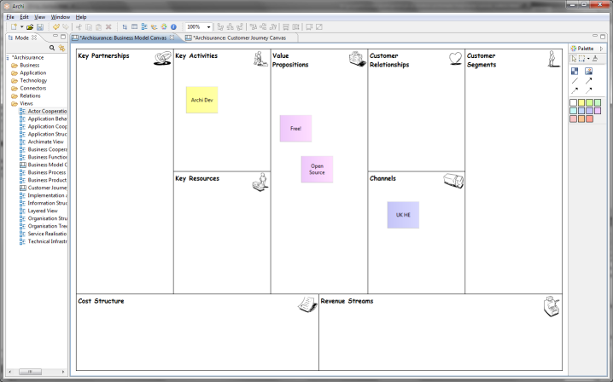  
The Business Model Canvas in Archi*

**Getting Started**

The quickest way to get started with the Canvas Modelling Toolkit is to create a new Canvas based on an existing template. We'll create a new [Business Model Canvas](http://www.businessmodelgeneration.com/canvas).

1. Create a new Empty Model in the Model Tree.
2. Select the "Views" folder on the Model Tree, right-click on it and select "New->Canvas from Template..."  
     
   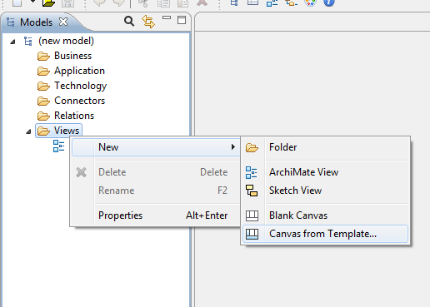
3. A wizard dialog window will open. Select the "Business Model Canvas" template from the templates in the "Installed Templates" section:  
     
   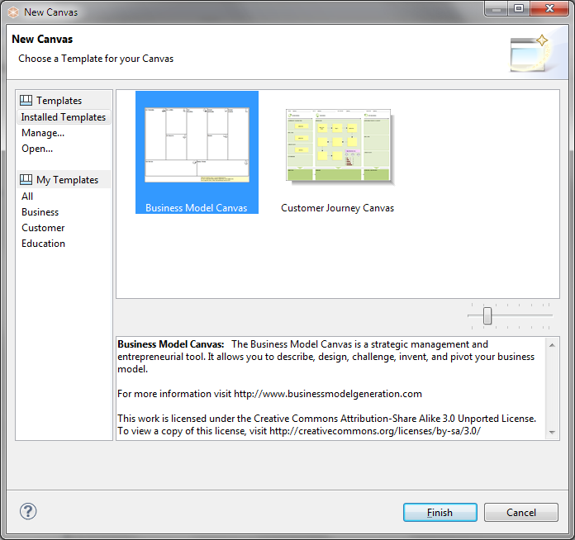
4. Press "Finish". A new "Business Model Canvas" View will appear in the Model Tree where you can edit the default name. The View itself will be open ready for you to edit:  
     
   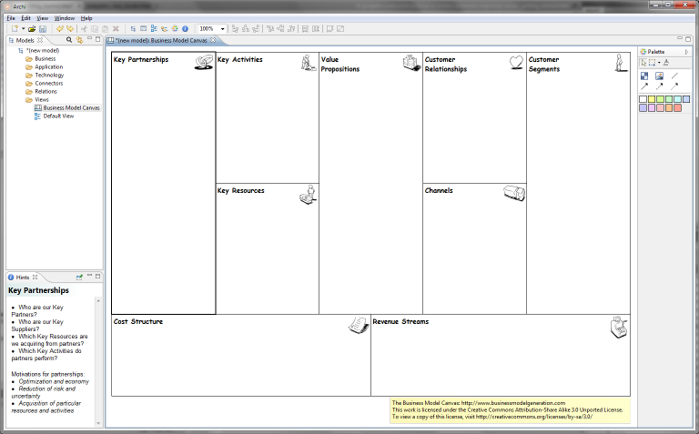

The Canvas consists of 9 empty "Blocks". Each Block acts as container that can contain "Stickies" and other elements that are added from the Palette. Each Block is currently locked so that you cannot move or resize it. Effectively, the Blocks act as backdrop containers. Each Block also has a textual "hint" associated with it that show in the Hints Window.

Add "Stickies" from the Palette and edit the text in the Sticky to create your Canvas model:

*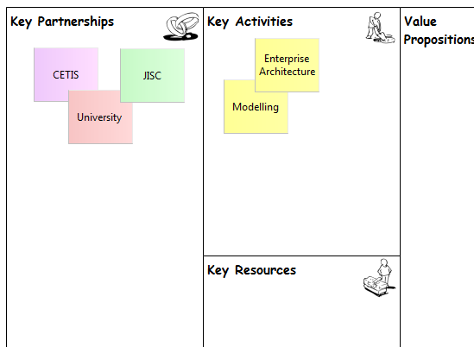  
Adding "Stickies" to the Canvas*

**Constructing a new Canvas - an Example**

Let's work through the process of constructing our own Canvas based on mapping Past, Present and Future concepts.

Assuming that you have a model selected in the Model Tree follow these steps:

1. Right click on the "Views" folder of your model on the Model Tree and select "New->Blank Canvas":  
     
   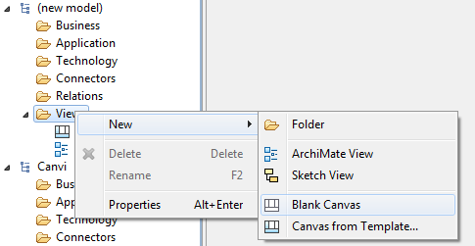
2. The Blank Canvas View will automatically open. You can rename it at this point in the Model Tree if you wish.
3. From the Palette select the Block tool and draw a tall rectangular Block on the Canvas. Edit its text content by clicking on it and changing it to "Past":  
     
   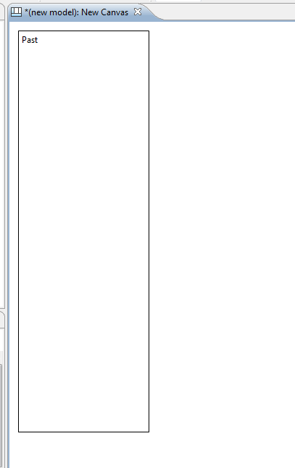
4. Create two more Blocks named "Present" and "Future" adding them to the Canvas so that they line up as follows:  
     
   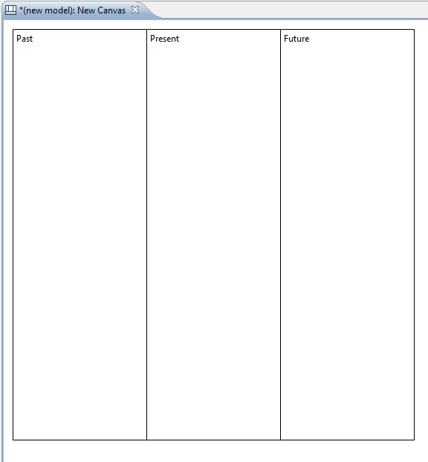
5. Now let's add some icons to these Blocks to make them visually more appealing. Double-click on the first Block to open the Properties Window. In the Properties Window select the "Image" tab. Then select the "Choose..." drop-down box and the "Set Image..." item:  
     
   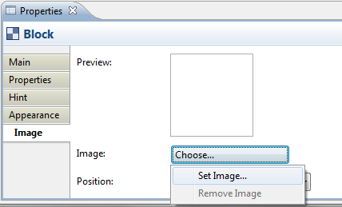  
     
   When the "My Images" Image Manager dialog window opens, select the "Open from File..." option and choose an appropriate image from your computer's file system. Do the same for the other Blocks.
6. Here's how it looks so far with the images that we have selected for the three Blocks:  
     
   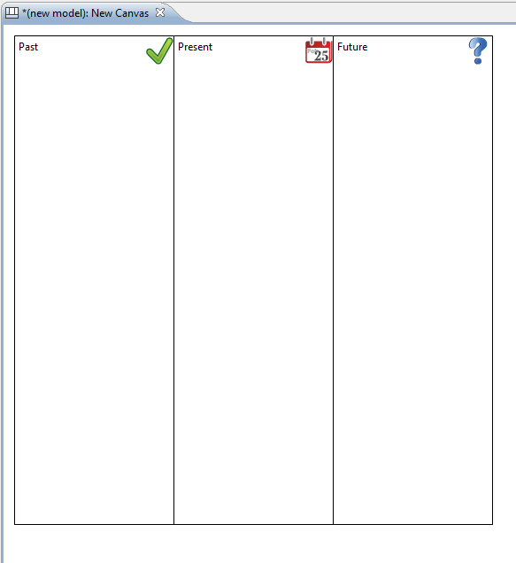
7. Now that we have constructed our three main Blocks we could take this opportunity to change their background colour, their text fonts and positions in the Properties Window. But for now let's add an Image underneath the Blocks. From the Palette select the Image tool and draw a rectangular Image place-holder on the Canvas right underneath the Blocks. Double-click on the Image place-holder to open the Properties Window. In the Properties Window on the "Main" tab select the "Choose..." drop-down box and the "Set Image..." item, as you did before for a Block, and select an appropriate image from your computer's file system. Then from the "Appearance" tab set the border to "None". The Canvas now looks like the following:  
     
   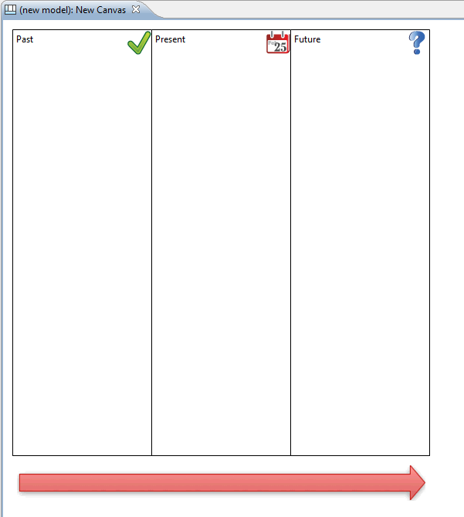

**Adding Hints and Locking**

For the finishing touches let's add some Hints to the Blocks and then lock them so that we can re-use the Canvas as a Template. Why do we want to add Hints to the Blocks? Well, as with the other elements in Archi models it's extremely helpful to provide a rubric that suggests to the end user the intent of the element and how it can be used in the model. Let's add the hints:

1. First ensure that the Hints Window is open. You can open it from the main "Window" menu.
2. Double-click on the first Block (the "Past" Block) in order to open the Properties Window.
3. In the Properties Window select the "Hint" tab.
4. Type "Past" for the Hint title, and some text for the Hint Content. Note that you can use HTML to mark up your content text. Here's what it looks like now:  
     
   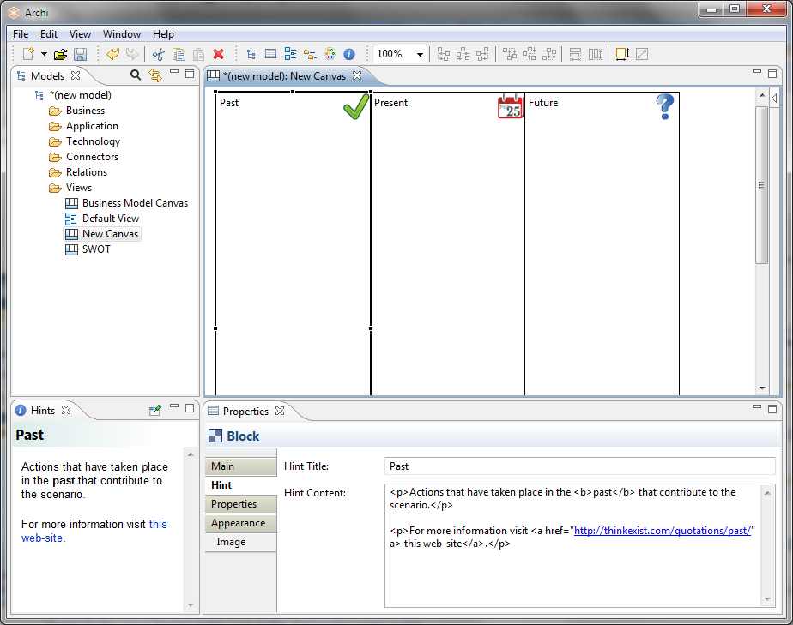
5. Add Hints for the other Blocks.
6. Now let's lock all these elements so that we can use the Canvas. Select each Block and the Image in turn. In the Properties Window tick the "Locked" checkbox:  
     
   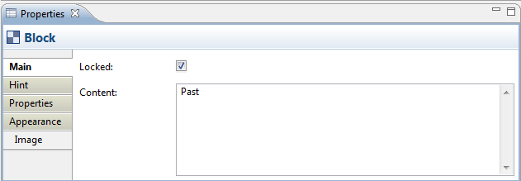

Now that we have created the Blocks, added an Image, provided the Hints and locked the elements we can save the whole thing as a Canvas Template and then create new instances of the Canvas from the template.

Creating a new Canvas instance from the template means we can now start using it for real:

*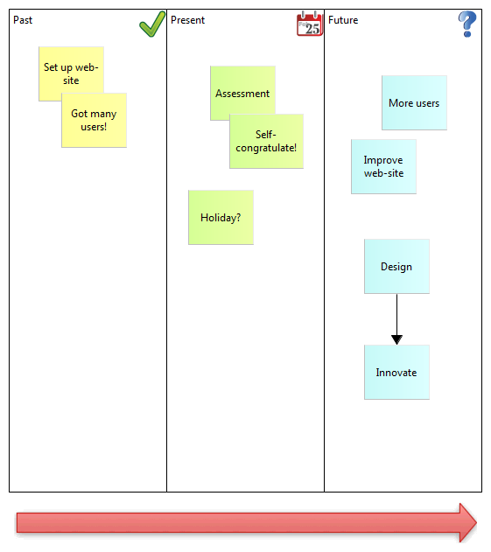  
Our imaginary Canvas*

For more ideas, look at how the built-in Canvas templates are constructed for further examples.

D:\projekts\code\archi\archi\uk.ac.bolton.archimate.help\help\img\tip.png**Archi uses a different file format for "*.archimate" files when adding Canvasses that contain images.**  
  
Normally Archi saves "*.archimate" files as single plain text XML format files. However, when images are used in a Canvas the file format used is a binary archive file (zip format) that contains both the model's XML file and any image files. This is to keep all related files together ensuring that you don't have to worry about managing the image files.

## ArchiMate connection tooltips now display the full meaning of the relationship

Some useful information can be revealed when the mouse cursor hovers over an ArchiMate connection to reveal a tooltip. The tooltip displays the relationship's name, its type, and some text that describes the nature of the relationship between the source and target elements.

*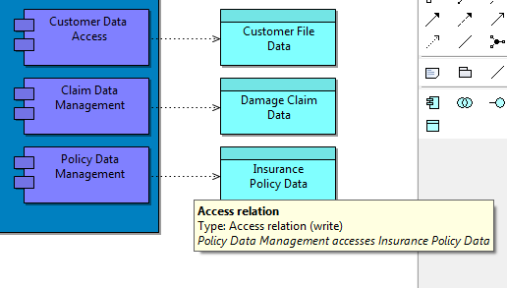  
A tooltip shows useful information when hovering over a connection*

## Cut/Copy/Paste/Select All shortcut keys now work in elements' label editors

In previous versions of Archi when directly editing the text inside elements in a View, the Cut/Copy/Paste/Select All shortcut keys did not work with selected text. This is now fixed.

## Holding down a key (Ctrl on Windows and Linux, Alt on Mac) when dragging elements from the Models Tree to a View ensures connections are not added

Existing elements and relationships can be added to a View by dragging and dropping them from the Model Tree to the View.

Normally, when you drag and drop elements from the Model Tree to a View any associated relationships are also added to the view as connections. There may be times when you do not want this to happen, you may simply wish to drag another instance of an element onto the View, for example. In order to do this, on Windows and Linux hold the Ctrl key down, or on Mac hold the Alt key down when dragging and dropping.

## Apple Mac Improvements

* Shortcut keys are now implemented for Mac OS X Lion full screen (press Escape to leave full screen mode). Also a menu item has been added to the main "Window" menu
* The Backspace key is now bound to the Delete command on Mac OS X. Previously this was accessed with the Fn+Backspace key
* The F1 key now invokes dynamic help on Mac OS X

## Improved Diagram Connection Line Styles

Connection lines between Notes and elements in ArchiMate Views, in Sketch Views are improved. You can specify the source and target arrow-heads and line-style:

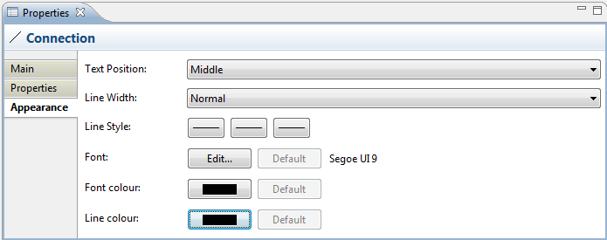

## A Relationship's name is now used as the text on a connection

In previous versions of Archi you had to set the text that displays for a relationship in a View separately in the “Appearance” tab in the Properties Window. This is now changed so that the relationship’s name is used for the connection text. This ensures that you only have to input it once for the relationship.